Serenity Site Implementation Specification
Serenity Site Implementation Specification 1
Version History 2
Access Information 2
How To Read This Document 3
Definitions 3
Schema Mapping Example 3
Schema – Detail Page (Example) 4
Site Implementation Overview 5
Page Types 5
Components 5
Site Functional Requirements 5
Custom Application Development 5
Application Functionality 5
Navigation Exports 5
XHTML Compliance and Cross-Browser Compatibility 8
Custom Scripts 8
Page Types 9
Home 9
Desktop Design - Home 9
Notes & Requirements 9
Page Builder 9
Schema - Home 10
Blog Detail 11
Desktop Design – Blog Detail 11
Notes & Requirements 11
Schema – Blog Detail 11
Components 13
General Components 13
Slide Component 13
Row - Features 13
Feature 14
Row – Recent Items 15
Row - CTA 16
Row - WYSIWYG 16
Component Name 17
Presentation Components 18
Component Name 18
Control Components 19
Search Engine Optimization 19
Section Control Component 20
Site Control Component 20
Presentation Content Units 21
Field Content Units 21

Version History
1.0 01/23/2019 Notes for internal review
2.0 04/22/2019 Changed to Section Control components for all page types.

Access Information
Design Templates: Provided by <design company>
Dev Site: trainer.ingeniuxondemand.us/serenity

How To Read This Document

Definitions
Template: See Page Type below.
Page Type: Page Types are the functional equivalent of templates in the Ingeniux CMS. They define the various content types that can be displayed on any given page in your site. Because Ingeniux is an XML-based system, the content itself is separate from the display, and any given content type has the potential to be displayed in multiple ways – on a web browser, a mobile device, or even rendered as a PDF file. Because of this, page types in Ingeniux CMS are very flexible, and one page type can often handle a number of different display requirements.
Component: Components are pieces of reusable content that are inserted into pages. For example, making an advertisement a component and inserting it into various pages designed for it will allow that same ad to appear throughout the site. This allows you to change content in one place, and have the result broadcast throughout the rest of your site where it is used.
Schema: A schema defines what elements on a defined page type or component are exposed in the CMS so they can be modified by the user. Each field described will be rendered on the Edit Form in the Ingeniux CMS.
Yellow Highlights: Items highlighted in yellow are open questions addressed to you (the customer) that need to be answered as we proceed.
Teal Highlights: Items highlighted in teal are comments addressed internally for Ingeniux developers, usually referring to specific ways to implement the features of the site. These will be removed from the final draft of the specification.

Schema Mapping Example
The example below shows how a schema for a Page Type or Component in this specification will map to the Edit Form of the Ingeniux CMS. Each row in the table defines each field in the page. The columns are defined as follows:
Label: Lists what the title of the field is on the Edit Form.
Element Type: Lists which element type will be used to store the content.
Notes: Any extra information about the element and its function.
Box #: Indicates which number in the box outs the individual field corresponds to.
R/H/RO: This notes whether the field is Required, Hidden and Read Only. If a field is Required, it must be filled in before a check in (new version) of a page can occur. If a field is Hidden, only Administrators can see the element on the Edit Form. If a field is Read Only, the field will be visible, but grayed out and unable to be modified.
The table below is how the schema is defined in this specification:

Schema – Detail Page (Example)
Label | Element Type | Notes | Help Text | Box # | R/H/RO
Title | Text
SubTitle | Text
Abstract | Text
Main Content Area | XHTML | Optional body copy content
Image | Component
Ancestor Nav | Navigation |  |  |  | R/H/RO
Site Control | Component | Banner and Footer |  |  | R/H/RO

Which will look like this in the Ingeniux CMS:

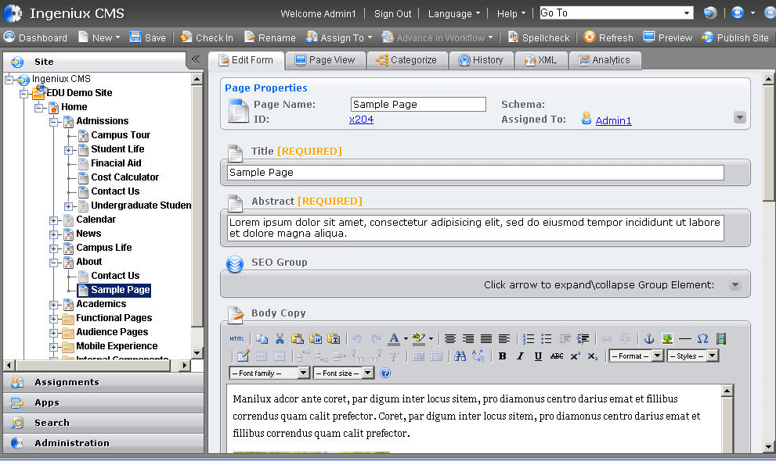

Site Implementation Overview
This section defines the site implementation scope of work and requirements for <customer name>. Site implementation will consist of:
- Creation of up to X responsive Page Types in Ingeniux CMS. The initial scope of work defined the following page types outlined below.
- Components as required to complete the specified Page Types.
Page Types required for this site implementation include:

Page Types
- Home
- Blog Index
- Blog Detail

Components
- SEO
- Site Control

Site Functional Requirements

Custom Application Development
<Describe custom API development here>

Application Functionality
- Search integration – use Lucene Search
- Print-this-Page – CSS for Print Functionality
- Social Sharing – Using ???

Navigation Exports
This site will require the following global exports to function. Global exports are created and managed in Administration > System Options > Publishing > Navigation Exports. Deleting these exports or changing the field names that they point to could cause issues with display of content in the site.
- Title
- Abstract
- Thumbnail Image

XHTML Compliance and Cross-Browser Compatibility
- Ingeniux will use W3C-standard HTML that meets accessibility compliance requirements.
- Ingeniux will provide cross-browser display for Firefox current version, Safari current version, IE 8 and above, and Chrome current version.
- Alt-text shall be used for all images throughout the site.

Custom Scripts

Fields will be placed in the site control and section controls for providing IDs for standard analytics systems including Google Analytics, Google Web Master tools and Bing Web Master tools. Custom script fields are also present for inserting scripts into the header or footer of every page in the site.

Each page type will also include fields for adding custom scripts to the header or footer of individual pages.

Label | Element Type | Notes | Help Text | Req’d | H / RO
Head Script | Text | Inserts a provided script into the <head> of the page, proper html should be used. |  |  | H/RO
Footer Script | Text | Inserts a provided script at the bottom of the page, proper html should be used. |  |  | H/RO

Page Types

Home

Desktop Design - Home
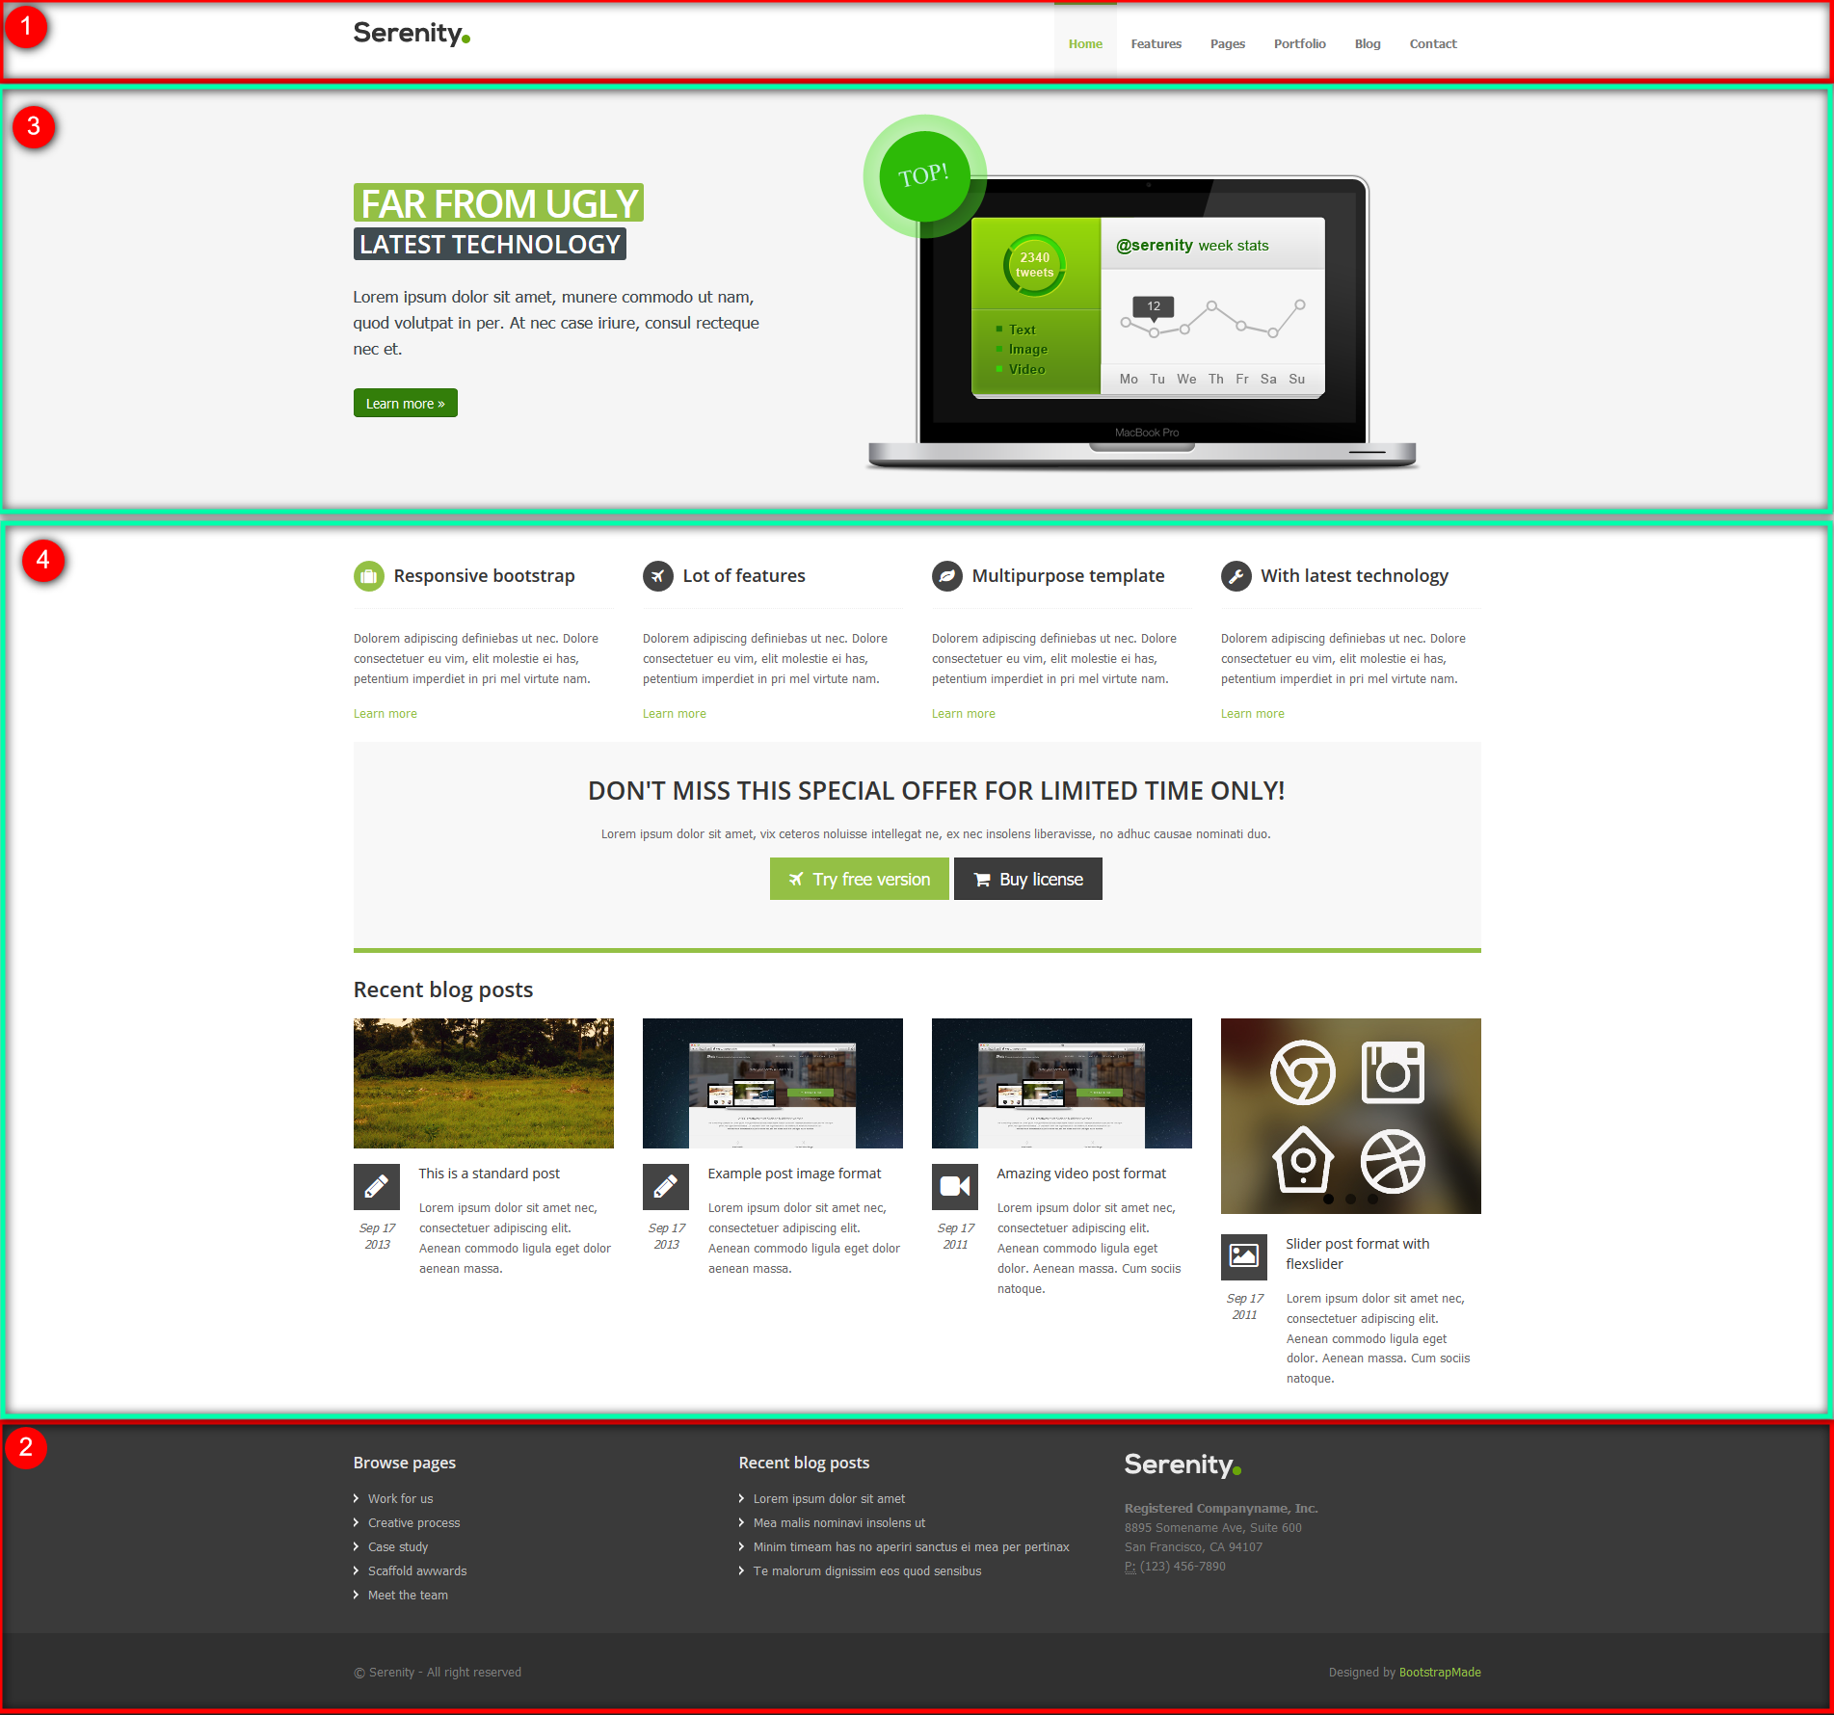

Notes & Requirements
- <Notes specific to this item go here>

Page Builder
Boxout #X will allow presentation targeting for changing the layout.

Allowed Presentation Content Units
Slideshow Component, All Field Content Units

Schema - Home
Label | Element Type | Notes | Help Text | Box # | R/H/RO
Title | Text |  | Fills in the h1 on the page and doubles as the SEO Browser Bar Title when that field is left blank on a live page. | N/A | R
Abstract | Text |  | Fill in with one or two short sentences describing the page. Used as a short description when internal links such as search results are made to this page. Also doubles as the Meta Description if that field is left blank. | N/A | R
Slideshow | List of Components | CompTypes: SlideComponent | Can add as many slides as desired, slides can use Start Date and End Date standard functionality for scheduling.
Content Rows | List of Components | CompTypes: RowFeatures, RowCTA, RowRecentItems, RowWYSIWYG | Components will display in rows in the order that they are put into the list.
Search Engine Optimization | Component | EmbeddedbyDefault: true |  |  | H
Custom Scripts | Group Start | See: Site Functional Requirements
Breadcrumb Navigation | Navigation | Navigation Type: Ancestors  Start Page: xID for the site folder.  Generation Order: down | Builds the breadcrumbs on the page, if any are shown. If not show, this element may also be used to supply other logic to the development of the page type and therefore should not be removed or modified. |  | R/H/RO
Section Control | Component | CompTypes:  SectionControl  Component:  Inherit from parent. Home will have a section control, so use that if no parent can be found. | Manually set where a new section should start. New pages made under a section will inherit from the closest ancestor via a custom hook in the API. |  | R/H/RO

Section

Desktop Design – Section
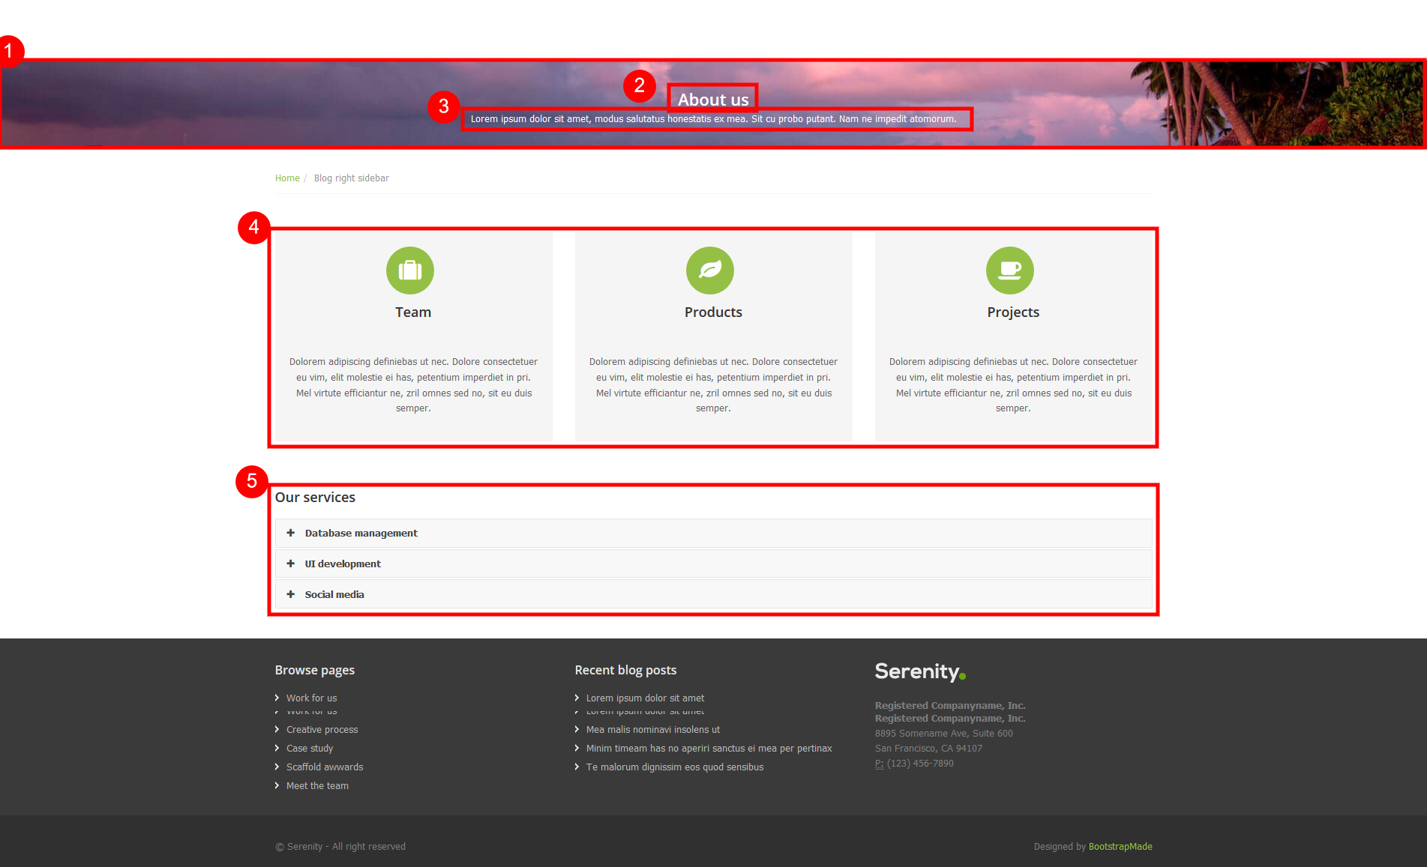

Notes & Requirements

Schema – Section
Label | Element Type | Notes | Help Text | Box # | R/H/RO
Banner Image | Asset | AssetTypes: Image | If this is set to an image, that image will display as the banner. If this is left blank, the banner image will inherit from the Section page that this page is a descendant of in the site tree. If there is no banner image on a section page above the area will display as a solid color. | 1
Title | Text |  | Fills in the h1 on the page and doubles as the SEO Browser Bar Title when that field is left blank on a live page. | 2 | R
Subtitle | Text |  |  | 3
Abstract | Text |  | Fill in with one or two short sentences describing the page. Used as a short description when internal links such as search results are made to this page. Also doubles as the Meta Description if that field is left blank. | N/A | R
Thumbnail | Asset | AssetType: Image
Icon | Dropdown | Values: TODO | Used when this item is linked somewhere that requires the display of an icon, such as in a feature on the home page. |  | R
Body Copy | XHTML |  | Displays above the index of blogs, can be used to introduce the blog, but not required.
Display Section Navigation | Checkbox | Default: true | Section navigation is coming from the section control. This automatically displays the children of this section page, one level deep. You can place pages in folders below this page and they will not display in the section navigation. Uncheck this box to hide the section navigation. | 4 | RO
Content Rows | List of Components | CompTypes: RowFeatures, RowCTA, RowRecentItems, RowWYSIWYG, RowAccordionMenu | Components will display in rows in the order that they are put into the list. | 5
Search Engine Optimization | Component | EmbeddedbyDefault: true |  |  | H
Custom Scripts | Group Start | See: Site Functional Requirements
Breadcrumb Navigation | Navigation | Navigation Type: Ancestors  Start Page: xID for the site folder.  Generation Order: down | Builds the breadcrumbs on the page, if any are shown. If not show, this element may also be used to supply other logic to the development of the page type and therefore should not be removed or modified. |  | R/H/RO
Section Control | Component | CompTypes:  SectionControl  Component:  Inherit from parent. Home will have a section control, so use that if no parent can be found. | Manually set where a new section should start. New pages made under a section will inherit from the closest ancestor via a custom hook in the API. |  | R/H/RO

Detail Page

Desktop Design – Detail Page
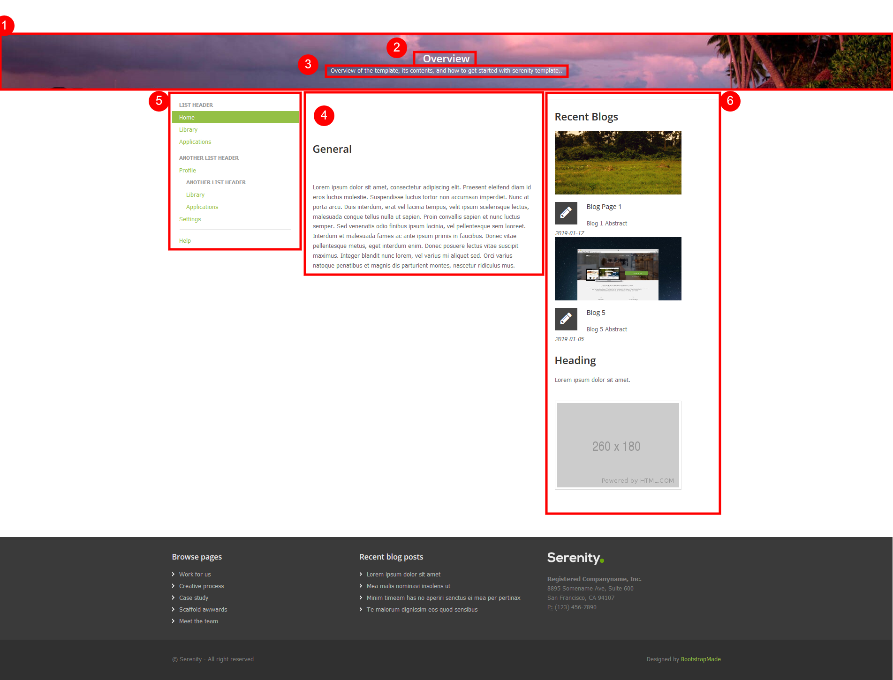

Notes & Requirements
- These should appear in the site below Section pages, or in folders under the home page for specific purposes such as Terms of Service and Privacy Policy.
- Usually used when a more specific page type doesn’t fit the need.
- Can be nested up to 2 levels deep under a page that starts a section in a section control and still appear in left navigation.

Schema – Detail Page
Label | Element Type | Notes | Help Text | Box # | R/H/RO
Banner Image | Asset | AssetTypes: Image | If this is set to an image, that image will display as the banner. If this is left blank, the banner image will inherit from the Section page that this page is a descendant of in the site tree. If there is no banner image on a section page above the area will display as a solid color. | 1
Title | Text |  | Fills in the h1 on the page and doubles as the SEO Browser Bar Title when that field is left blank on a live page. | 2 | R
Subtitle | Text |  |  | 3
Abstract | Text |  | Fill in with one or two short sentences describing the page. Used as a short description when internal links such as search results are made to this page. Also doubles as the Meta Description if that field is left blank. | N/A | R
Thumbnail | Asset | AssetType: Image
Icon | Dropdown | Values: TODO | Used when this item is linked somewhere that requires the display of an icon, such as in a feature on the home page. |  | R
Body Copy | XHTML |  | Displays above the index of blogs, can be used to introduce the blog, but not required. | 4
Display Left Navigation | Checkbox | Default: true | Left navigation is coming from the section control. This automatically displays the children of this section page, two levels deep. You can place pages in folders and they will not display in the left navigation. Uncheck this box to hide the left navigation. | 5
Content Rows | List of Components | CompTypes: RowWYSIWYG, RowImageandLink | Components will display in rows in the order that they are put into the list. Displays below the Body Copy. | N/A
Right Sidebar | List of Components | CompTypes:  RowRecentItems; RowWYSIWYG; RowImageandLink |  | 6
Search Engine Optimization | Component | EmbeddedbyDefault: true |  |  | H
Custom Scripts | Group Start | See: Site Functional Requirements
Breadcrumb Navigation | Navigation | Navigation Type: Ancestors  Start Page: xID for the site folder.  Generation Order: down | Builds the breadcrumbs on the page, if any are shown. If not show, this element may also be used to supply other logic to the development of the page type and therefore should not be removed or modified. |  | R/H/RO
Section Control | Component | CompTypes:  SectionControl  Component:  Inherit from parent. Home will have a section control, so use that if no parent can be found. | Manually set where a new section should start. New pages made under a section will inherit from the closest ancestor via a custom hook in the API. |  | R/H/RO

Blog Index

Desktop Design – Blog Index
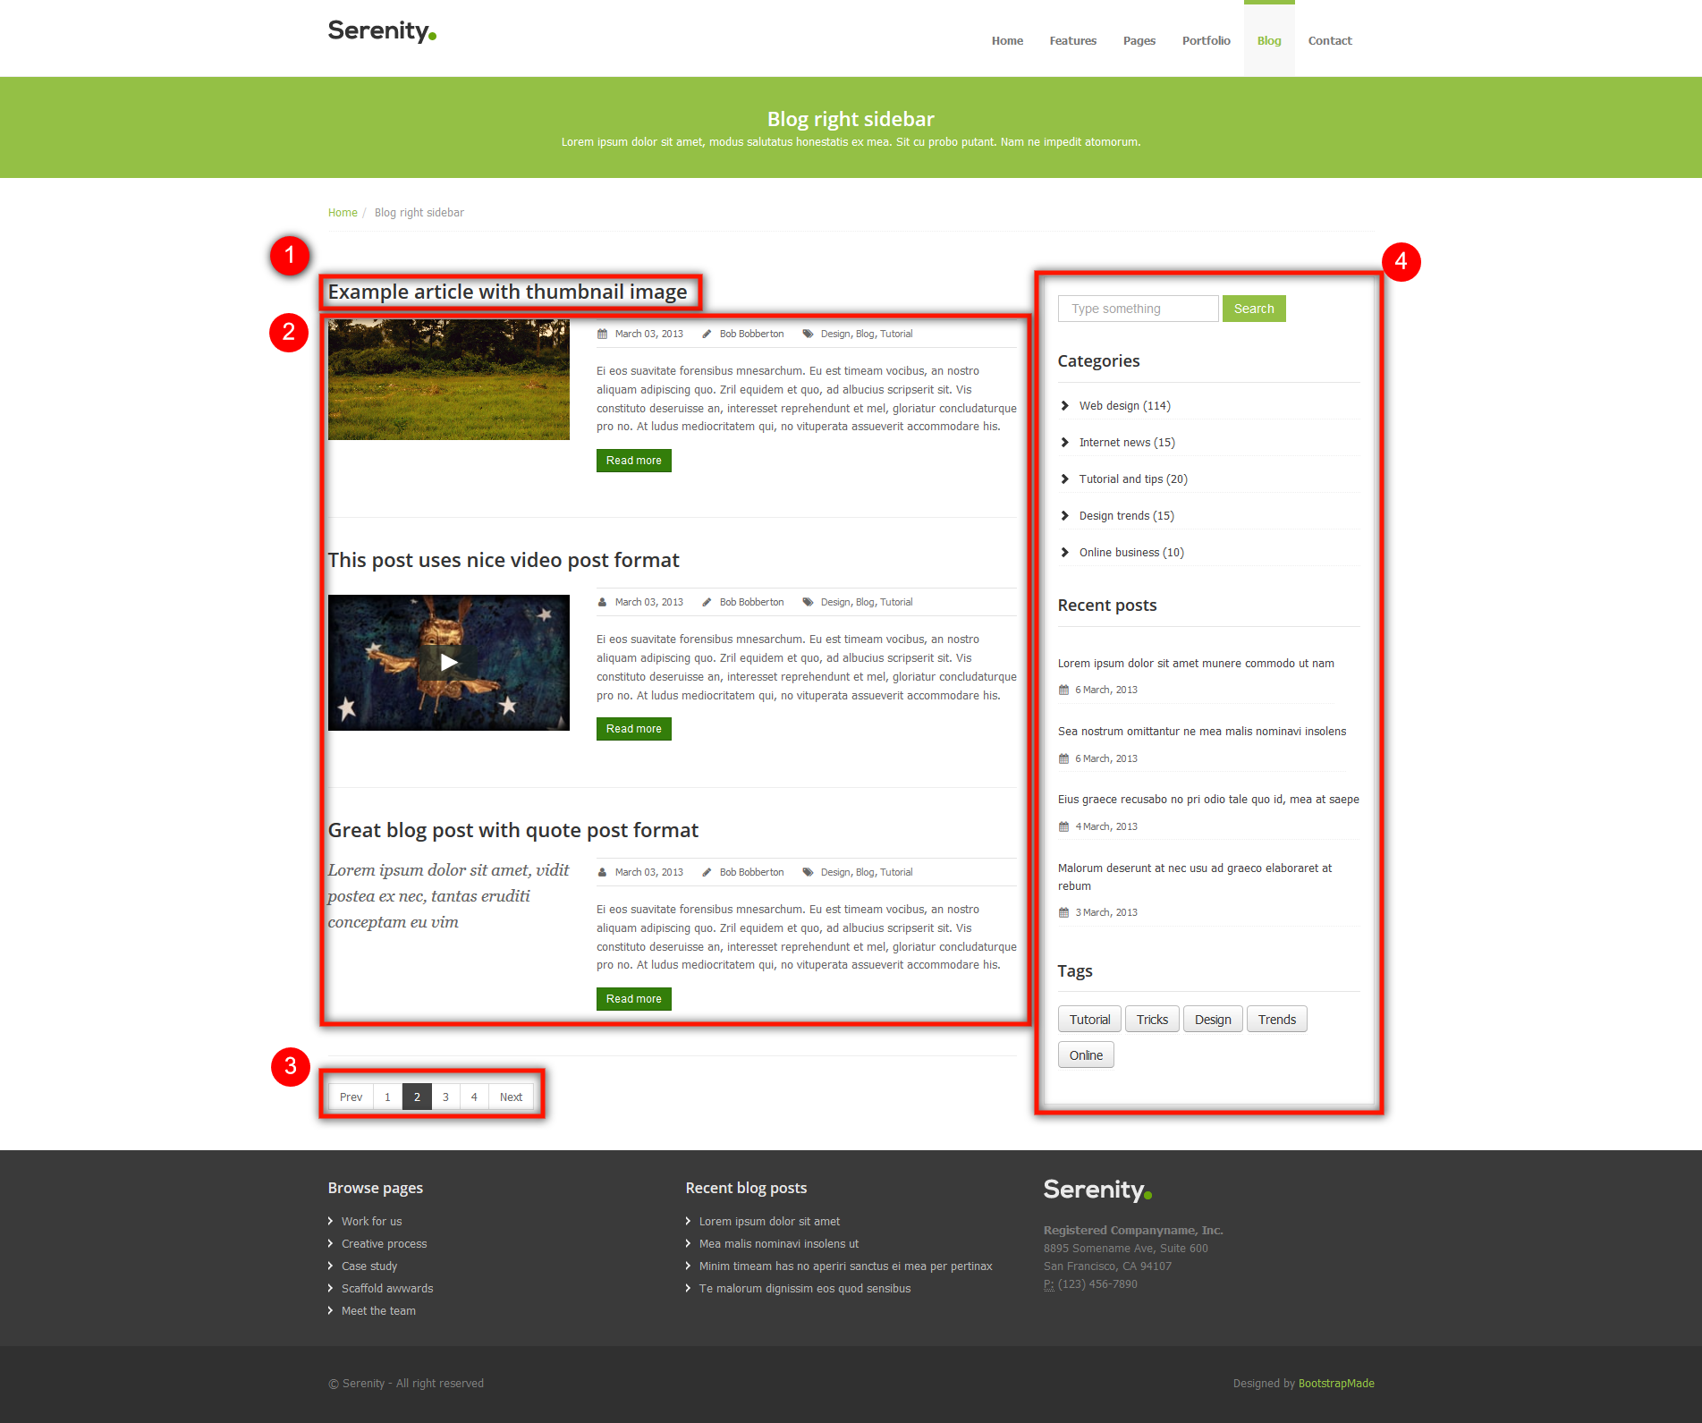

Notes & Requirements
- Blog Index pages can be indexed by other blog index pages so have all applicable meta data.

Schema – Blog Index
Label | Element Type | Notes | Help Text | Box # | R/H/RO
Title | Text |  | Fills in the h1 on the page and doubles as the SEO Browser Bar Title when that field is left blank on a live page. | N/A | R
Abstract | Text |  | Fill in with one or two short sentences describing the page. Used as a short description when internal links such as search results are made to this page. Also doubles as the Meta Description if that field is left blank. | N/A | R
Thumbnail | Asset | AssetType: Image
Icon | Dropdown | Values: TODO | Used when this item is linked somewhere that requires the display of an icon, such as in a feature on the home page. |  | R
Body Copy | XHTML |  | Displays above the index of blogs, can be used to introduce the blog, but not required.
Blog Index | Navigation | Type: Children  MaxDepth: 3 | Indexes up to three levels of depth to allow for folder structure for organization of blogs.
Right Side Bar | List of Components | CompTypes:  TagList; RowRecentItems;
Search Engine Optimization | Component | EmbeddedbyDefault: true |  |  | H
Custom Scripts | Group Start | See: Site Functional Requirements
Breadcrumb Navigation | Navigation | Navigation Type: Ancestors  Start Page: xID for the site folder.  Generation Order: down | Builds the breadcrumbs on the page, if any are shown. If not show, this element may also be used to supply other logic to the development of the page type and therefore should not be removed or modified. |  | R/H/RO
Section Control | Component | CompTypes:  SectionControl  Component:  Inherit from parent. Home will have a section control, so use that if no parent can be found. | Manually set where a new section should start. New pages made under a section will inherit from the closest ancestor via a custom hook in the API. |  | R/H/RO

Blog Detail

Desktop Design – Blog Detail
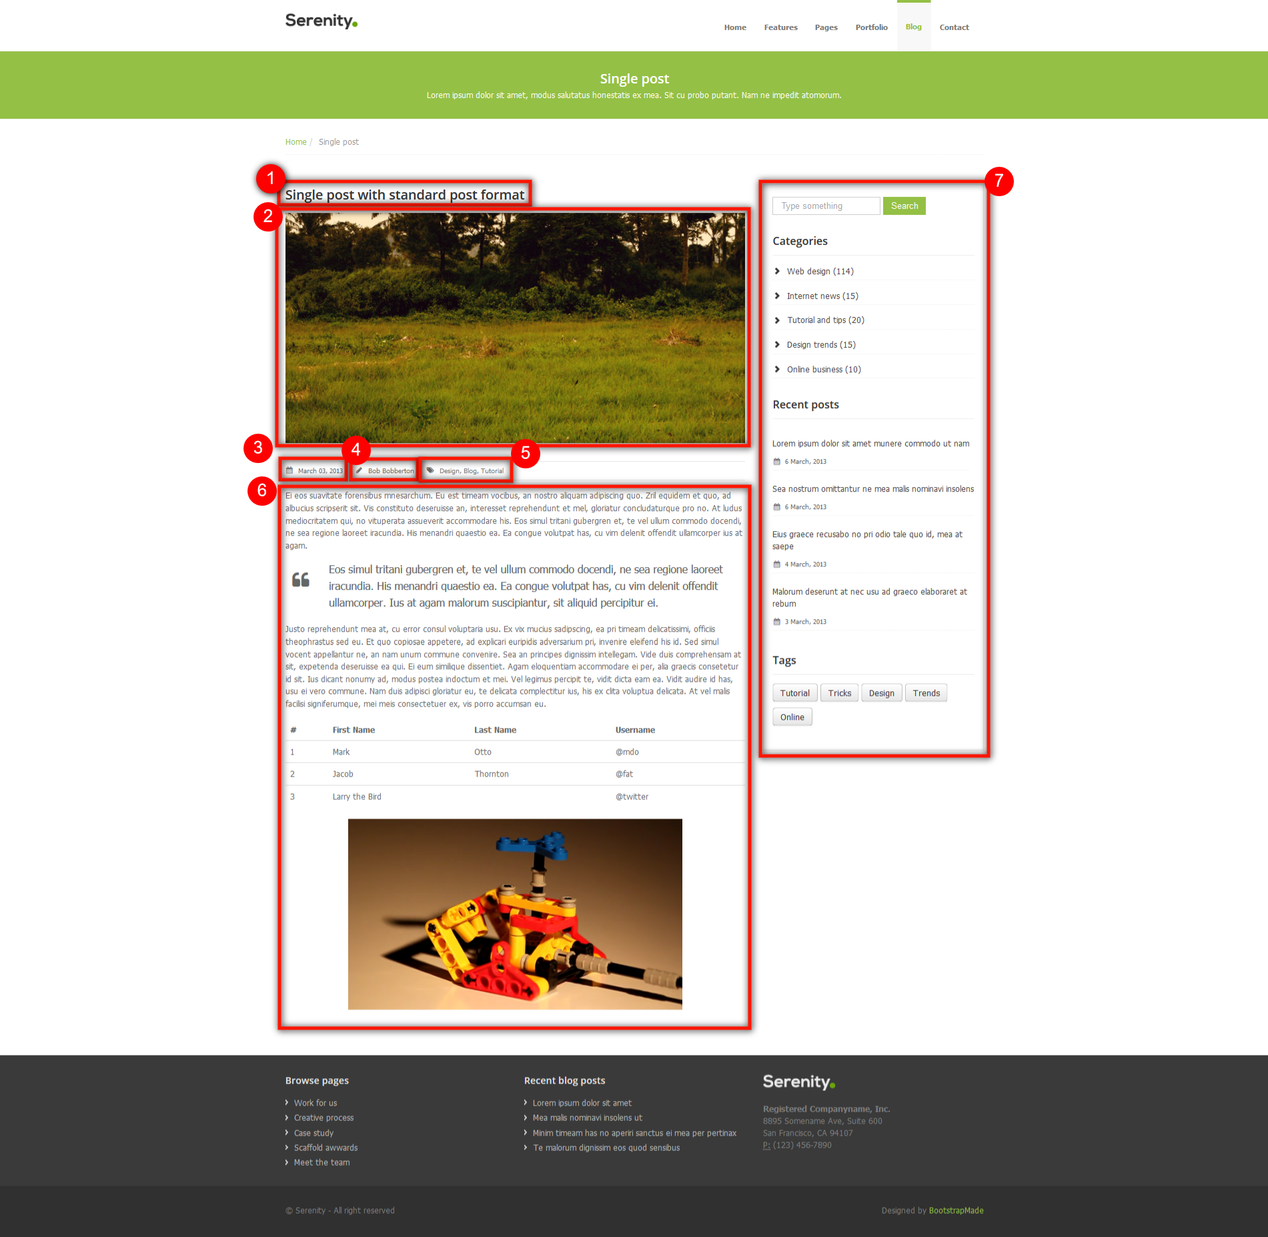

Notes & Requirements
- Blog detail pages will appear in folder structures for organization by year and month.
- Blog detail pages always appear under a blog index page type in the IA.
- Number 5 in the design boxout does not have any fields on the page to control its display. Categories are matched up against a taxonomy navigation in the Site Control (Blog Categories), all such categories applied to the page that appear display here in alphabetical order.

Schema – Blog Detail
Label | Element Type | Notes | Help Text | Box # | R/H/RO
Title | Text |  | Fills in the h1 on the page and doubles as the SEO Browser Bar Title when that field is left blank on a live page. | N/A | R
Abstract | Text |  | Fill in with one or two short sentences describing the page. Used as a short description when internal links such as search results are made to this page. Also doubles as the Meta Description if that field is left blank. | N/A | R
Main Image | Asset | AssetType: Image
Thumbnail | Asset | AssetType: Image
Publication Date | Local Date |  |  |  | R
Author | Link
Display Blog Categories | Checkbox | Default: true | Categories are matched up against a taxonomy navigation in the Site Control (Blog Categories), all such categories applied to the page that appear display here in alphabetical order.
Icon | Dropdown | Values: TODO | Used when this item is linked somewhere that requires the display of an icon, such as in a feature on the home page. |  | R
Body Copy | XHTML
Body Components | List of Components | CompTypes: RowWYSIWYG; RowCTA; RowEditorialItems; RowVideo; RowTable; RowBlockquote
Right Side Bar | List of Components | CompTypes:  TagList; RowRecentItems;
Search Engine Optimization | Component | EmbeddedbyDefault: true |  |  | H
Custom Scripts | Group Start | See: Site Functional Requirements
Breadcrumb Navigation | Navigation | Navigation Type: Ancestors  Start Page: xID for the site folder.  Generation Order: down | Builds the breadcrumbs on the page, if any are shown. If not show, this element may also be used to supply other logic to the development of the page type and therefore should not be removed or modified. |  | R/H/RO
Section Control | Component | CompTypes:  SectionControl  Component:  Inherit from parent. Home will have a section control, so use that if no parent can be found. | Manually set where a new section should start. New pages made under a section will inherit from the closest ancestor via a custom hook in the API. |  | R/H/RO

Search Listing

Desktop Design – Search Listing
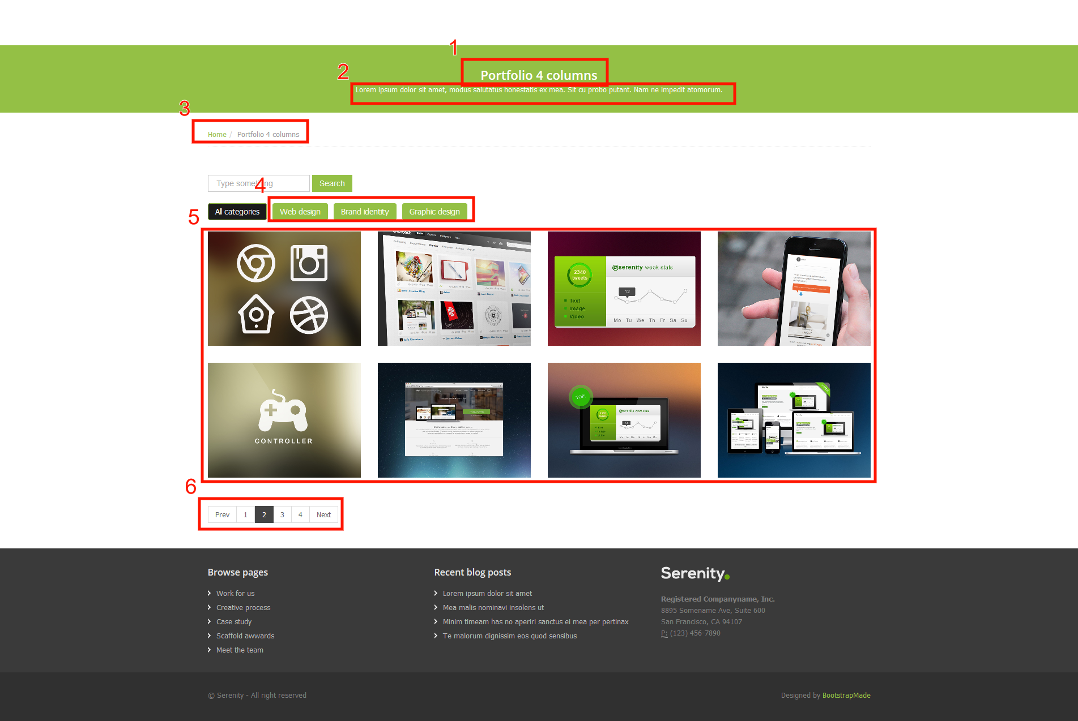

Notes & Requirements
- This is just the template from which all pages will start to be built as schemas.

Schema – Search Listing
Label | Element Type | Notes | Help Text | Box # | R/H/RO
Title | Text |  | Fills in the h1 on the page and doubles as the SEO Browser Bar Title when that field is left blank on a live page. | 1 | R
Abstract | Text |  | Fill in with one or two short sentences describing the page. Used as a short description when internal links such as search results are made to this page. Also doubles as the Meta Description if that field is left blank. | 2 | R
Thumbnail | Asset | AssetType: Image |  | N/A | R
Publication Date | Local Date |  |  | N/A | R
Icon | Dropdown | Values: TODO | Used when this item is linked somewhere that requires the display of an icon, such as in a feature on the home page. | N/A | R
Body Copy | XHTML | Not displayed in boxout, but if used will appear above the search results.
Category Filters | Taxonomy Navigation | IncludePages: false  Depth: 1 | Display only categories that have items in the result set to display. | 4
Search Results Component | Component | CompTypes: IGXSearch_Local  EmbeddedByDefault: false  LockEmbedState: true |  | 5
Number of Items per Pagination | Plain Text | Default: 8 |  | 6
Search Engine Optimization | Component | EmbeddedbyDefault: true |  | N/A | H
Custom Scripts | Group Start | See: Site Functional Requirements
Breadcrumb Navigation | Navigation | Navigation Type: Ancestors  Start Page: xID for the site folder.  Generation Order: down | Builds the breadcrumbs on the page, if any are shown. If not show, this element may also be used to supply other logic to the development of the page type and therefore should not be removed or modified. | 3 | R/H/RO
Section Control | Component | CompTypes:  SectionControl  Component:  Inherit from parent. Home will have a section control, so use that if no parent can be found. | Manually set where a new section should start. New pages made under a section will inherit from the closest ancestor via a custom hook in the API. |  | R/H/RO

Portfolio Detail

Desktop Design – Portfolio Detail
N/A

Notes & Requirements
- This is just the template from which all pages will start to be built as schemas.

Schema – Portfolio Detail
Label | Element Type | Notes | Help Text | Box # | R/H/RO
Title | Text |  | Fills in the h1 on the page and doubles as the SEO Browser Bar Title when that field is left blank on a live page. | N/A | R
Abstract | Text |  | Fill in with one or two short sentences describing the page. Used as a short description when internal links such as search results are made to this page. Also doubles as the Meta Description if that field is left blank. | N/A | R
Thumbnail | Asset | AssetType: Image |  |  | R
Publication Date | Local Date |  |  |  | R
Icon | Dropdown | Values: TODO | Used when this item is linked somewhere that requires the display of an icon, such as in a feature on the home page. |  | R
Mail Image | Asset | AssetTypes: Image
Body Copy | XHTML |  | Displays above the index of blogs, can be used to introduce the blog, but not required.
Search Engine Optimization | Component | EmbeddedbyDefault: true |  |  | H
Custom Scripts | Group Start | See: Site Functional Requirements
Breadcrumb Navigation | Navigation | Navigation Type: Ancestors  Start Page: xID for the site folder.  Generation Order: down | Builds the breadcrumbs on the page, if any are shown. If not show, this element may also be used to supply other logic to the development of the page type and therefore should not be removed or modified. |  | R/H/RO
Section Control | Component | CompTypes:  SectionControl  Component:  Inherit from parent. Home will have a section control, so use that if no parent can be found. | Manually set where a new section should start. New pages made under a section will inherit from the closest ancestor via a custom hook in the API. |  | R/H/RO

Search Results

Desktop Design – Search Results
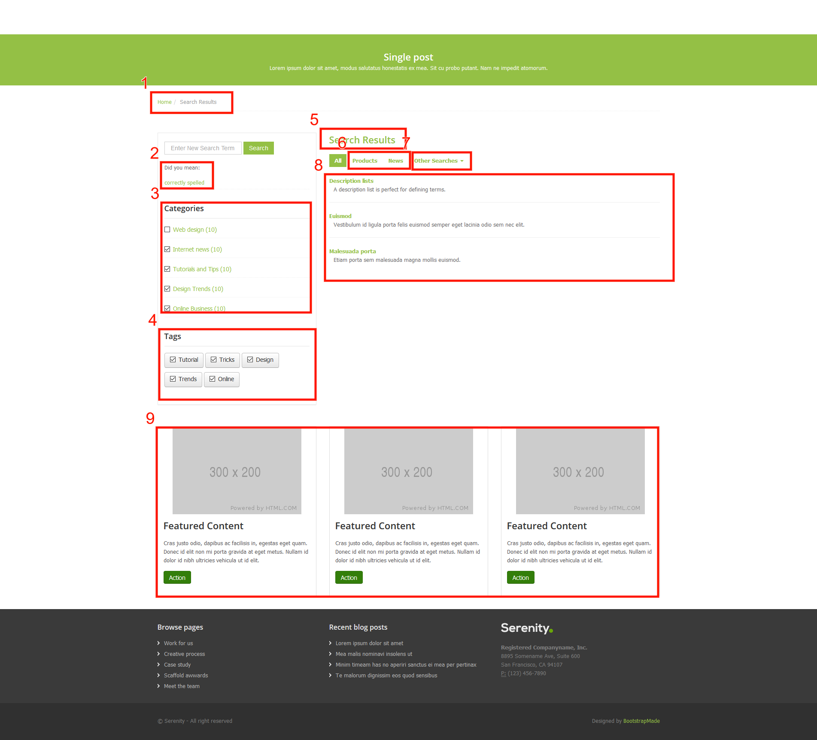

Notes & Requirements
- This is the search results page for the entire site. Most likely only one instance of this page will be made from the schema.

Schema – Search Results
Label | Element Type | Notes | Help Text | Box # | R/H/RO
Title | Text |  | Fills in the h1 on the page and doubles as the SEO Browser Bar Title when that field is left blank on a live page. | 5 | R
Abstract | Text |  | Fill in with one or two short sentences describing the page. Used as a short description when internal links such as search results are made to this page. Also doubles as the Meta Description if that field is left blank. | N/A | R
Thumbnail | Asset | AssetType: Image |  | N/A | R
Icon | Dropdown | Values: TODO | Used when this item is linked somewhere that requires the display of an icon, such as in a feature on the home page. | N/A | R
Search Navigation  Bar | List of Text | List Item Label: Schema Root Name (No Spaces) | Each item in the list should be the root element name of the schema that you want to provide a search filter for. Only one schema per list item. | 6
Other Search Links | List of Links |  |  | 7
Category Filters | Taxonomy Navigation | IncludePages: false  Depth: 1 | Display only categories that have items in the result set to display. | 3
Tag Filters | Taxonomy Navigation | IncludePages: false  Depth: 1 |  | 4
Search Results Component | Component | CompTypes: IGXSearch_Local  EmbeddedByDefault: false  LockEmbedState: true |  | 8
Number of Items per Pagination | Plain Text | Default: 7
Keymatch Results Component | Component | CompTypes: IGXKeyMatch_Local  EmbeddedByDefault: false  LockEmbedState: true |  | 9
Search Suggest Results Component | Component | CompTypes: IGXSuggest_Local  EmbeddedByDefault: false  LockEmbedState: true |  | 2
Search Engine Optimization | Component | EmbeddedbyDefault: true |  | N/A | H
Custom Scripts | Group Start | See: Site Functional Requirements
Breadcrumb Navigation | Navigation | Navigation Type: Ancestors  Start Page: xID for the site folder.  Generation Order: down | Builds the breadcrumbs on the page, if any are shown. If not show, this element may also be used to supply other logic to the development of the page type and therefore should not be removed or modified. | 1 | R/H/RO
Section Control | Component | CompTypes:  SectionControl  Component:  Inherit from parent. Home will have a section control, so use that if no parent can be found. | Manually set where a new section should start. New pages made under a section will inherit from the closest ancestor via a custom hook in the API. | N/A | R/H/RO

Page Starter

Desktop Design – Page Starter
N/A

Notes & Requirements
- This is just the template from which all pages will start to be built as schemas.

Schema – Page Starter
Label | Element Type | Notes | Help Text | Box # | R/H/RO
Title | Text |  | Fills in the h1 on the page and doubles as the SEO Browser Bar Title when that field is left blank on a live page. | N/A | R
Abstract | Text |  | Fill in with one or two short sentences describing the page. Used as a short description when internal links such as search results are made to this page. Also doubles as the Meta Description if that field is left blank. | N/A | R
Thumbnail | Asset | AssetType: Image |  |  | R
Publication Date | Local Date |  |  |  | R
Icon | Dropdown | Values: TODO | Used when this item is linked somewhere that requires the display of an icon, such as in a feature on the home page. |  | R
Body Copy | XHTML |  | Displays above the index of blogs, can be used to introduce the blog, but not required.
Search Engine Optimization | Component | EmbeddedbyDefault: true |  |  | H
Custom Scripts | Group Start | See: Site Functional Requirements
Breadcrumb Navigation | Navigation | Navigation Type: Ancestors  Start Page: xID for the site folder.  Generation Order: down | Builds the breadcrumbs on the page, if any are shown. If not show, this element may also be used to supply other logic to the development of the page type and therefore should not be removed or modified. |  | R/H/RO
Section Control | Component | CompTypes:  SectionControl  Component:  Inherit from parent. Home will have a section control, so use that if no parent can be found. | Manually set where a new section should start. New pages made under a section will inherit from the closest ancestor via a custom hook in the API. |  | R/H/RO

Components

General Components

Slide Component

Design – Slide Component
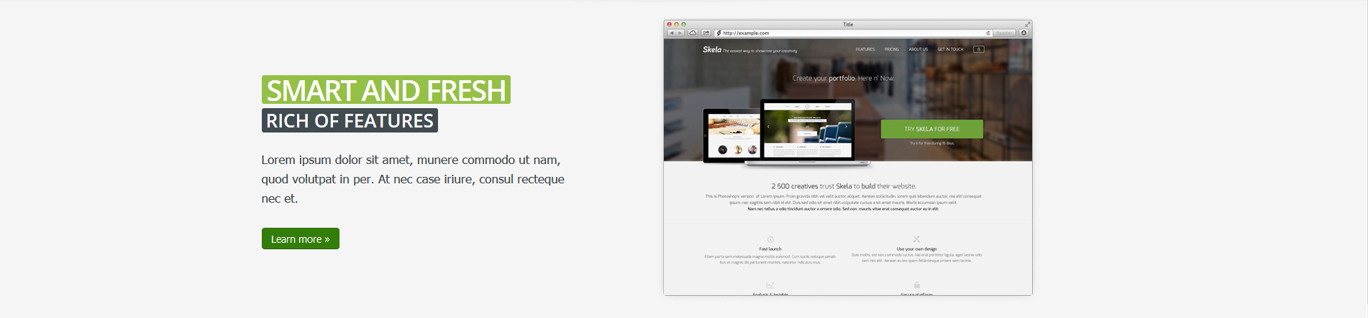

Notes & Requirements
- <Notes specific to this item go here>

Used In:
Home

Schema – Slide Component

Label | Element Type | Notes | Help Text | Box # | R/H/RO
Heading | Text |  |  |  | R
Subheading | Text
Copy | XHTML Editor
Button Link | Link |  | Fills in the text and URL of the button. |  | R
Image | Image | AssetTypes: Image

Row – Accordion Menu

Design – Row – Accordion Menu
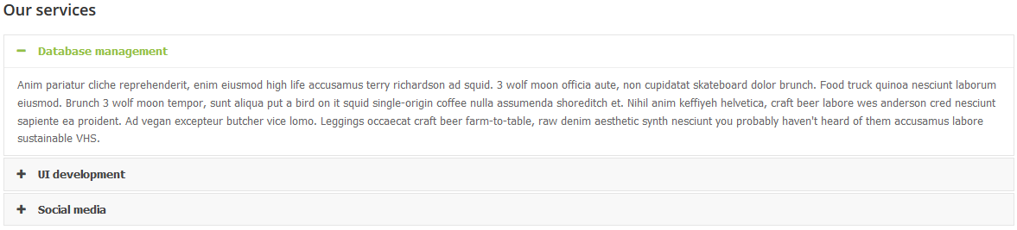

Notes & Requirements
- Embedding this item can get bulky, since it has subcomponents in a list.

Used In:
Section

Schema – Row – Accordion Menu

Label | Element Type | Notes | Help Text | Box # | R/H/RO
Heading | Text
Accordion Items | List of Components | CompTypes: AccordionItem

Row – Accordion Item

Design –Accordion Item
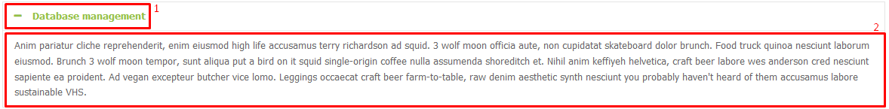

Notes & Requirements
- This component should probably be embedded into the Accordion Menu.

Used In:
Accordion Menu

Schema – Accordion Item

Label | Element Type | Notes | Help Text | Box # | R/H/RO
Heading | Text |  |  | 1 | R
Copy | XHTML |  |  | 2

Row - Features

Design – Row – Features
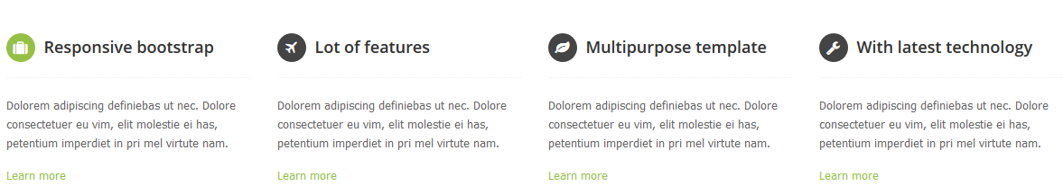

Notes & Requirements
- <Notes specific to this item go here>

Used In:
Home

Schema – Row - Features

Label | Element Type | Notes | Help Text | Box # | R/H/RO
Icon | Dropdown | Values: TBD
Heading | Text
Copy | XHTML Editor
Link | Link

Feature

Design – Feature

Notes & Requirements
- Each component is an individual feature in the Row – Features component. Should probably be embedded to save confusion and unnecessary xID incrementation.

Used In:
Row - Features

Schema – Feature

Label | Element Type | Notes | Help Text | Box # | R/H/RO
Icon | Dropdown | Values: TBD
Heading | Text
Copy | XHTML Editor
Link | Link

Row – Editorial Items

Design – Row – Editorial Items
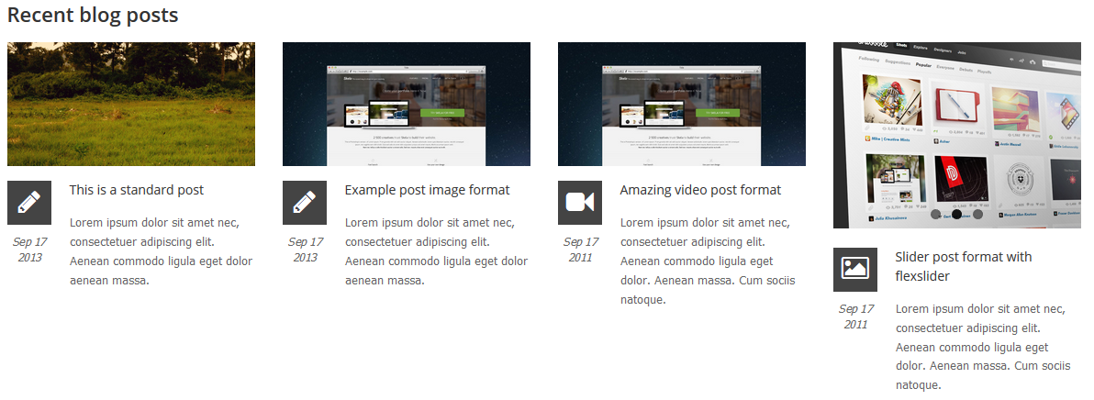

Notes & Requirements
- Used when a list of items inside the CMS needs to be featured in a manually ordered fashion.

Used In:
Home

Schema – Row - Editorial Items

Label | Element Type | Notes | Help Text | Box # | R/H/RO
Heading | Text
Editorial Links | Link Set | PageTypes: BlogDetail | The LinkSet title doesn't display.

Row – Recent Items

Design – Row - Recent Items

Notes & Requirements
- Shows the 4 most recent items that appear in the navigation, ordered by publication date.

Used In:
Home

Schema – Row - Recent Items

Label | Element Type | Notes | Help Text | Box # | R/H/RO
Heading | Text
Items Navigation | Navigation | Type: Children  Depth: 3 | Start at a folder that contains items that can be ordered by a Publication Date.

Row - CTA

Design – Row – CTA
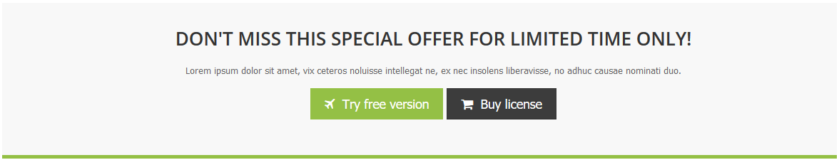

Notes & Requirements
- <Notes specific to this item go here>

Used In:
Home

Schema – Row - CTA

Label | Element Type | Notes | Help Text | Box # | R/H/RO
Heading | Text
Copy | XHTML Editor
Primary Button | Link |  | Fills in the URL and link text of the button.
Primary Icon | Dropdown | Values: TODO | Icon that appears in the primary button.
Secondary Button | Icon |  | Fills in the URL and link text of the button.
Secondary Icon | Dropdown | Values: TODO | Icon that appears in the secondary button.

Row - Blockquote

Design – Row – Blockquote
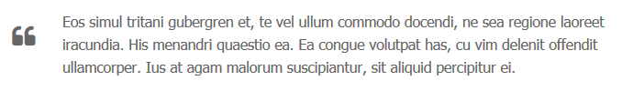

Notes & Requirements
- <notes>

Used In:
<Link to schemas that accept this component>

Schema – Row - Blockquote

Label | Element Type | Notes | Help Text | Box # | R/H/RO
Quote | Text |  | Automatically wraps in blockquote with a left aligned quote icon. No HTML allowed.

Row – Image and Link

Design – Row – Image and Link
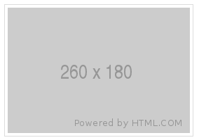

Notes & Requirements
- <Notes specific to this item go here>

Used In:
Home

Schema – Row – Image and Link

Label | Element Type | Notes | Help Text | Box # | R/H/RO
Image | Asset | AssetTypes: Image |  |  | R
Link | Link |  | Wraps around the image.

Row - Table

Design – Row – Table
N/A

Notes & Requirements
- Create instances of this component with properly formatted tables for embedding.

Used In:
<Link to schemas that accept this component>

Schema – Row - Table

Label | Element Type | Notes | Help Text | Box # | R/H/RO
Table Content | XHTML

Tag List

Design – Tag List

Notes & Requirements
- <Notes specific to this item go here>

Used In:
Blog Index, Blog Detail

Schema – Tag List

Label | Element Type | Notes | Help Text | Box # | R/H/RO
Heading | Text
Tags | Taxonomy Navigation | Depth: 1 | Either manually pick a list of categories to display, will display in alphabetical order. Or, choose a container category and the children will display in alphabetical order. Only categories with items tagged will display.
Display Style | Dropdown | Values: list buttons  Default: list |  |  | R
Blog Index | Link |  | Link to the blog index page that will be the destination for filter clicks. |  | R

Row – Video

Design – Row – Video
N/A

Notes & Requirements
- Be sure to wrap in div with class of row.

Used In:
<Link to schemas that accept this component>

Schema – Row - Video

Label | Element Type | Notes | Help Text | Box # | R/H/RO
YouTube Embed URL | Text

Row - WYSIWYG

Design – Row – WYSIWYG
N/A

Notes & Requirements
- Be sure to wrap in div with class of row.

Used In:
<Link to schemas that accept this component>

Schema – Row - WYSIWYG

Label | Element Type | Notes | Help Text | Box # | R/H/RO
Heading | Text
WYSIWYG | XHTML

Virtual Link Component

Design – Virtual Link Component

Notes & Requirements
- This component is used to place a link into a navigation where a page normally would be. This can be used to link to internal pages, external pages, or documents. Can also be pulled in through taxonomy.

Used In:
Navigations, Feature Areas

Schema – Virtual Link Component

Label | Element Type | Notes | Help Text | Box # | R/H/RO
Title | Text |  | Fills in the h1 on the page and doubles as the SEO Browser Bar Title when that field is left blank on a live page. | N/A | R
Abstract | Text |  | Fill in with one or two short sentences describing the page. Used as a short description when internal links such as search results are made to this page. Also doubles as the Meta Description if that field is left blank. | N/A | R
Thumbnail | Asset | AssetType: Image |  |  | R
Publication Date | Local Date |  |  |  | R
Icon | Dropdown | Values: TODO | Used when this item is linked somewhere that requires the display of an icon, such as in a feature on the home page. |  | R
Virtual Link | Link |  |  |  | R
Additional Query Strings | Plain Text

Component Name

Design – Component Name

Notes & Requirements
- <Notes specific to this item go here>

Used In:
Home

Schema – Component Name

Label | Element Type | Notes | Help Text | Box # | R/H/RO

Presentation Components

Component Name

Design – Component Name

Notes & Requirements
- <Notes specific to this item go here>

Used In:
<Link to schemas that accept this component>

Schema – Component Name

Label | Element Type | Notes | Help Text | Box # | R/H/RO

Control Components

SEO

Notes & Requirements
- Each page type will include a pre-embedded component with the same SEO and Social Sharing fields. Embedding will be locked
- In addition, a Default Twitter Site and Default Sharing Image will be set in the Site Control.

Label | Element Type | Notes | Help Text | Box # | R/H/RO
Navigation Override | text | Should be implemented for Breadcrumbs, top navigations, left navigations and the like. | Used to override the name and title of the page in automated navigation elements, such as breadcrumbs, top navigation and left navigation.
Descriptive Title | text |  | Used to populate the title attribute of internal links to the page to provide a more descriptive option for accessibility or SEO.
Browser Bar Title | text |  | Populates the title bar on the browser or current tab in the browser. Used by search engines to identify the page.
Meta Description | text |  | Fill in one or two concise descriptive sentences to describe the page for search engines.
Keywords | text |  | A list of comma separated keywords or phrases that describe the content of the page. Limit to 10-15 unique words or phrases.
No Index | checkbox |  | If checked, will request that search engines avoid including this specific page.
No Follow | checkbox |  | If checked, will request that search engines avoid following the links on this specific page, and thereby avoid relating this page and its site to the linked to pages and sites.
Priority | enumeration | Default Value: 0.5  Choices: 0.1 0.2 0.3 0.4 0.5 0.6 0.7 0.8 0.9 1.0 | Set to a number for how you deem this page ranks in importance compared to other pages in the site. Does not affect search results but helps the search engine determine which order to index the site. Default is 0.5.
InSite Search Keymatch | Plain text |  | These space delimited terms will be used to place featured content on search results page that exactly match the search term.
Social Media Sharing | groupstart |  | Contains elements that facilitate presentation when this page is shared.
Type | enumeration | Default Value: website  Choices: website article place product restaurant.menu video.other | Determines how the link will be presented when shared on social media sites, such as Facebook. Read about OpenGraph for more information or choices.
Sharing Title | text |  | The title for the content when shared on Facebook. Defaults back to the Title if not filled in.
Sharing Description | text |  | The description for the content when shared on Facebook. Defaults back to the Meta Description if not filled in.
Sharing Image | image |  | The image for the content when shared on Facebook. Defaults back to the Default Sharing Image in the Site Control if not filled in.
Twitter Card | dropdown | Values: summary photo gallery product app player  Default Value: summary | The card type, which will be one of "summary", "photo", "gallery", "product", "app", or "player".
Twitter Creator | Text | Default Value: | @username for the content creator / author.
 | groupend

Section Control

Design – Section Control

<May want one design per responsive level.>

Notes & Requirements
- Defaulted to be placed in automatically by xID.
- Uses a custom hook to automatically inherit the section control from the nearest parent in the site tree upon page creation. If no section control can be found on a parent, this will use the section control that is being used on the home page. If that is blank, the section control won’t populate and the page will have no site control content to display and may error.

Used In:
All Page Types.

Schema – Section Control
Label | Element Type |  | Notes | Help Text | Box # | R/H/RO
Site Control | Component |  | Component: xID of Site Control Component instance.
Left Navigation Heading | Link |  |  | Used to get the heading of the left nav by querying the Title of the page you link to in this link.
Left Navigation | Navigation |  | Type: Children  Depth: 2 | Start page should be the section that contains the items that should be displayed in the left navigation.
Right Sidebar |  | List of Components | CompTypes:  RowRecentItems; RowWYSIWYG; RowImageandLink
Inheritance Paradigm |  | Dropdown | Value: predicate override localonly  Default: predicate

Site Control Component

Design – Site Control Component

<May want one design per responsive level.>

Notes & Requirements
- Defaulted to be placed in automatically by xID.
- <Notes specific to this item go here>

Used In:
Home

Schema – Site Control Component
Label | Element Type | Notes | Help Text | Box # | R/H/RO
Logo | Asset | AssetType: Image
Logo Link | Link |  | Covers the header and footer logos.
Top Navigation | Navigation | Type: Children  Depth: 2 | Start at the home page, populates the nav bar and the dropdowns.
Footer Links 1 | LinkSet
Footer Links 2 | LinkSet
Footer Logo | Asset | AssetType: Image
Contact Info | XHTML
Global Settings | Group Start
Blog Categories | Taxonomy Navigation | IncludePages: false
Authors | List of Links |  | Link to all author pages or components for reference in navigations.
No Results Message | XHTML | Default: No results to display. | Will display on search results page when there are no results to display.
Search Results | Link |  | Link to the search results page.
 | Group End

Left Navigation Divider

Design – Left Navigation Divider

Notes & Requirements
- <Notes specific to this item go here>

Used In:
Site Tree

Schema – Left Navigation Divider

Label | Element Type | Notes | Help Text | Box # | R/H/RO
Heading | Text |  | Leave blank to just have a divider.
Show Divider | Checkbox | Default: true | Uncheck to have a heading without a divider under it.

Presentation Content Units

Notes & Requirements
- Presentation Content Units will be built to full width to fit in columns they are placed in.
- Fields should be tested for blank and display the name of the field in square brackets while in preview to allow for easier editing in Design mode. Example: [Heading 2]

Field Content Units

Schema – Heading 2

Label | Element Type | Notes | Help Text | R/H/RO
Heading 2 | Plain Text |  | Displays text in an h2 tag.

Schema – Heading 3

Label | Element Type | Notes | Help Text | R/H/RO
Heading 3 | Plain Text |  | Displays text in an h3 tag.

Schema – Heading 4

Label | Element Type | Notes | Help Text | R/H/RO
Heading 4 | Plain Text |  | Displays text in an h4 tag.

Schema – Heading 5

Label | Element Type | Notes | Help Text | R/H/RO
Heading 5 | Plain Text |  | Displays text in an h5 tag.

Schema – Heading 6

Label | Element Type | Notes | Help Text | R/H/RO
Heading 6 | Plain Text |  | Displays text in an h6 tag.

Schema – Copy Block
Label | Element Type | Notes | Help Text | R/H/RO
Copy Block | XHTML Editor

Schema – Image
Label | Element Type | Notes | Help Text | R/H/RO
Image | Image

Schema – Editorially Featured News
Label | Element Type | Notes | Help Text | R/H/RO
Links | Link Set | PageTypes: NewsDetail

Schema – Categorically Featured News
Label | Element Type | Notes | Help Text | R/H/RO
Category | Taxonomy Navigation | PageTypes: NewsDetail  IncludePages: true

